Use the My Disney Experience App to Improve Your Disney Vacation

There is so much that goes into a Walt Disney World vacation that it can seem overwhelming. When you need to book a hotel, park tickets, FastPasses, and dining reservations at separate times, it can be a bit challenging to remember all of those reservations.

Luckily, My Disney Experience can make planning your Walt Disney World family vacation so much easier. It’s a free planning tool that you can use before and during your Disney vacation. It’s easy to download to your phone, and there is free WiFi around the Walt Disney World resort to make sure you can connect.

Wondering how My Disney Experience works to help you plan and manage your Disney vacation? Here’s what to expect when you use it.

Tips For Using My Disney Experience

It’s free to download the mobile app, so make sure you do it when you start planning your vacation. Once you have it installed, you can start setting it up. You’ll also be able to use the website in addition to the app for many of your reservations. However, once you are on Disney property, you’ll want to have the app ready.
If you also visit Disneyland, you’ll use the separate Disneyland app. They are two separate apps, although you’ll be able to use the same login ID and password.

My Disney Experience is also a website, and you can make your plans using your computer. I still like having the app, however, because it’s especially helpful when you are on the go.
To get started, you’ll want to set up an account with your email address and a password. If you’ve already booked some or all of your trip, you probably already have an account set up. Disney accounts and passwords are the same throughout all of their sites.

Walt Disney World resort hotel rooms don’t need to be booked through the app, and they usually link automatically if you’ve used your email address. Your reservations should show on your account. If not, you can use your confirmation number to link them.

With the app, you’ll be able to get directions to the hotel, find information about amenities, activities, and restaurants at your resort. You can do this both on property and off property, so you can see everything even before you arrive.
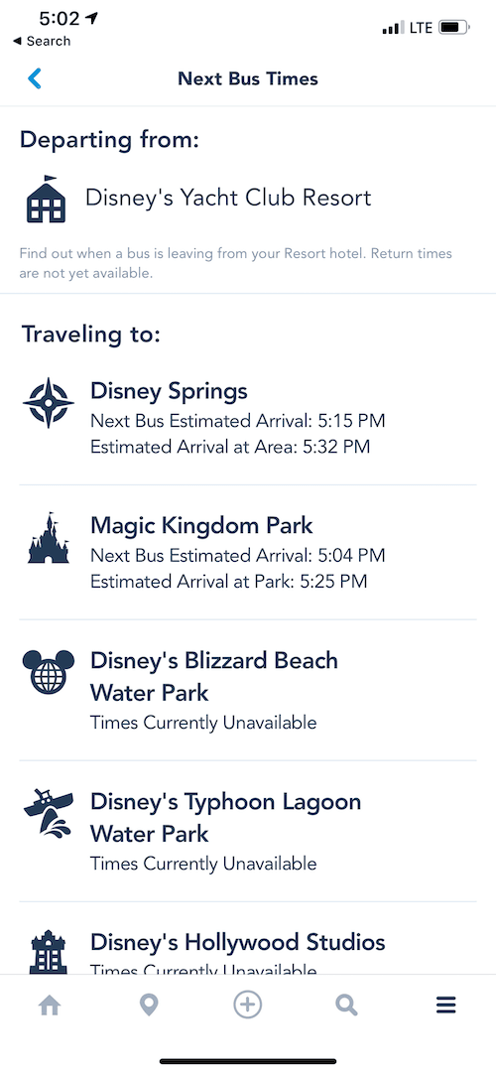
You’ll also be able to see bus times in the app. Right now, the app shows the schedule for buses from your resort to the parks.

Next, you’ll link your Disney Parks tickets to your account if you’ve got paper tickets. It’s easy to do in the app – you can scan the code, or input the numbers directly. If you have an annual pass, it should automatically show up in the app.
Do this well in advance of your trip so you can make dining and FastPass+ reservations before you leave. If you don’t already have tickets, you can purchase them within the app.
Then, you can choose FastPass+ reservations. These can also be done in the park, while you are there. Remember to make any popular FastPass experiences well in advance (60 days for resort guests, 30 days for off-property guests).

Now, after you use the first three FastPass selections you have for the day, you can make additional reservations, and the app is a great way to do that on the go. Do it as soon as you use your last reserved one, so you can have the most options.

MyDisneyExperience also allows the option to see current attraction wait times, where different characters are meeting guests, as well as the locations for the nearest restrooms right in the app.
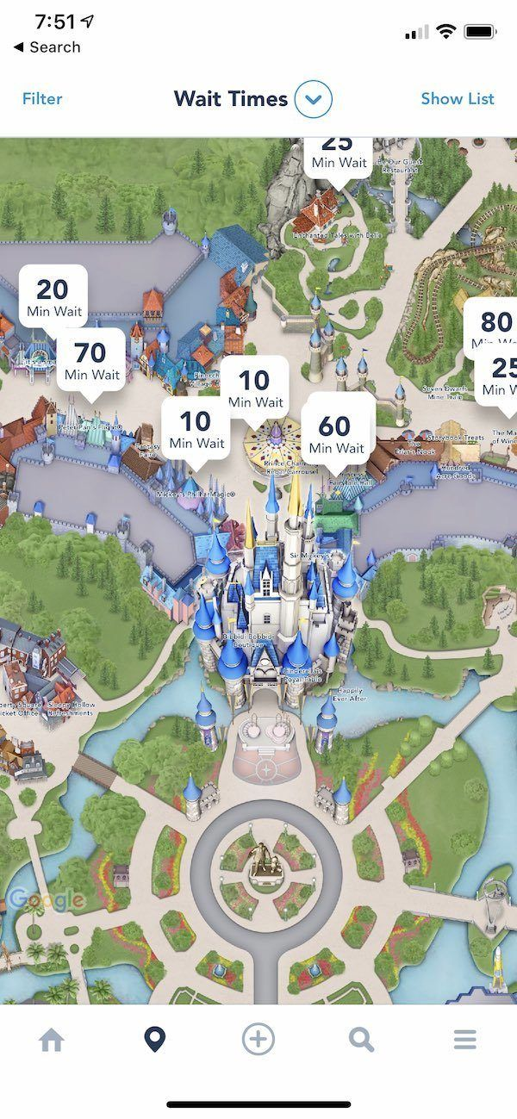
You can even see menus and other available times, right through the app. Looking at the menus through the mobile app is a good way to know if a restaurant is a good option for your family, without having to walk to the restaurant.
Some quick-service locations throughout the park will let you order food through the app. This can be a great way to avoid lines, and you’ll be able to pay right through the app as well.
Mobile ordering is definitely a great way to save time when trying to do as much as possible at Walt Disney World. Since many guests don’t use that option, the lines are typically much shorter.

Entertainment options are also available through the My Disney Experience app. You’ll find locations and times for specific shows for the day.

If you want to get information about events and tours, there’s a tab on the app that can show you. If you’ve enabled location services and are in the park, it will also show you how far you’ll need to go. You can also get park hours of each park, which can help you make decisions on the fly.

You can also use the My Disney Experience app to find out what the current wait times are for every attraction within the parks. If you don’t have a FastPass+ reservation, this is a great way to decide whether or not you want to walk over to an attraction.

It’s also good to use if a particular ride happens to be down. You can use the app to see when it’s running again, so you won’t have to keep walking over.

Using Memory Maker? Use the app to buy Memory Maker, view/link pictures, and show your Disney PhotoPass code. When you use your MagicBand, your attraction photos will appear automatically in your account.

The app also now includes a link from the Disney Play app so you can stay entertained while walking around the park and waiting in lines. When your location services are turned on, you’ll even get an alert when there is the option to use the Disney Play app.
There’s also a tab where you can shop from the Disney Parks online store. From the app, you can order items online, or see on a map where they are sold. It’s a nice option if you don’t see your size in one store, but still want to purchase the item. You won’t need to stop into each store until you find the right item and size.

The My Disney Experience app can definitely help you make changes and updates to your trip in advance of your trip, as well as during your stay. Download it before you go to make your trip even better!

Some families like to purchase MagicBand accessories (you’ll get a solid color MagicBand free if you are staying on property) and autograph books in advance of their vacation.

